Llyn Brenig Fish Identifications

Here at Llyn Brenig we have several different species of fish that live in the lake. Below I have included some pictures of each along with some helpful information to help identify them.
To start with we have the “wild” species. These are fish that are found in most lakes in the surrounding areas that have found their way in naturally. This may be through means of connecting water ways, wildlife transfers and other things such as angling!

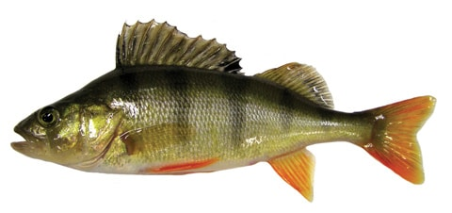
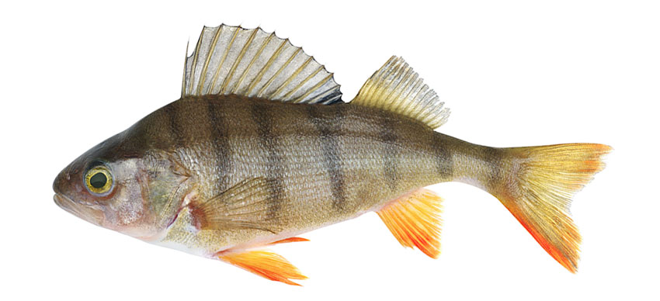
Perch

The Perch is a small to medium freshwater predatory fish that lives in shoals. Their diet consists mainly of small crustaceans and other small fish species including each other. The larger they get the more solitary they become. Some defining features include:

- Darck vertical stripes along the body.
- A tall spikey dorsal fin.
- Red/orange pelvic and anal fins

Pike
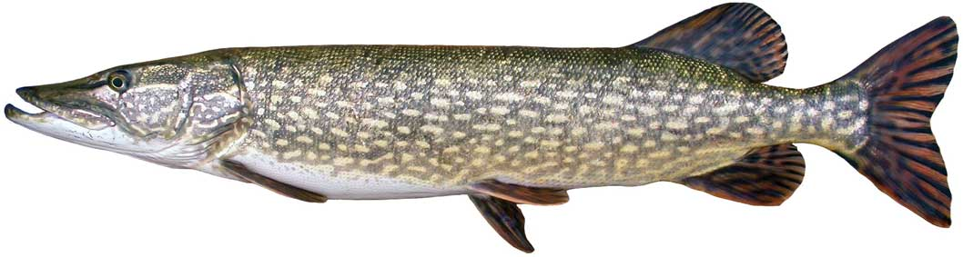

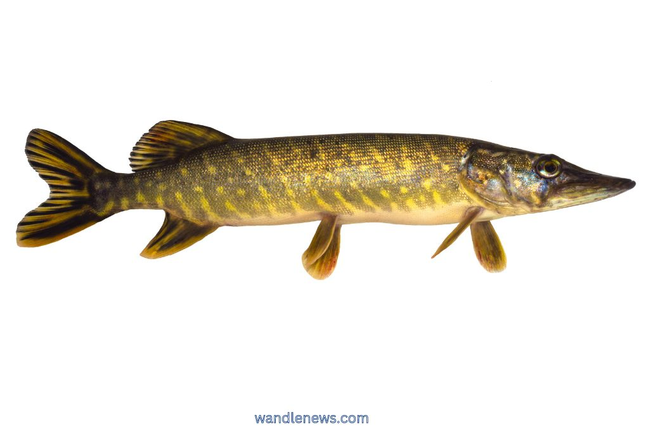

The Pike is long bodied predatory freshwater fish with a long snout and large teeth. There diet consists of other small freshwater species and as they grow larger will also eat other things such as other pike, rainbow trout and baby ducklings! Pike can grow to enormous sizes with weights exceeding 40lbs.
Some defining features include:
- Olive green colouration with lighter yellow spotting
- Large fins towards the rear for fast burst of acceleration
- White colouration to underside.

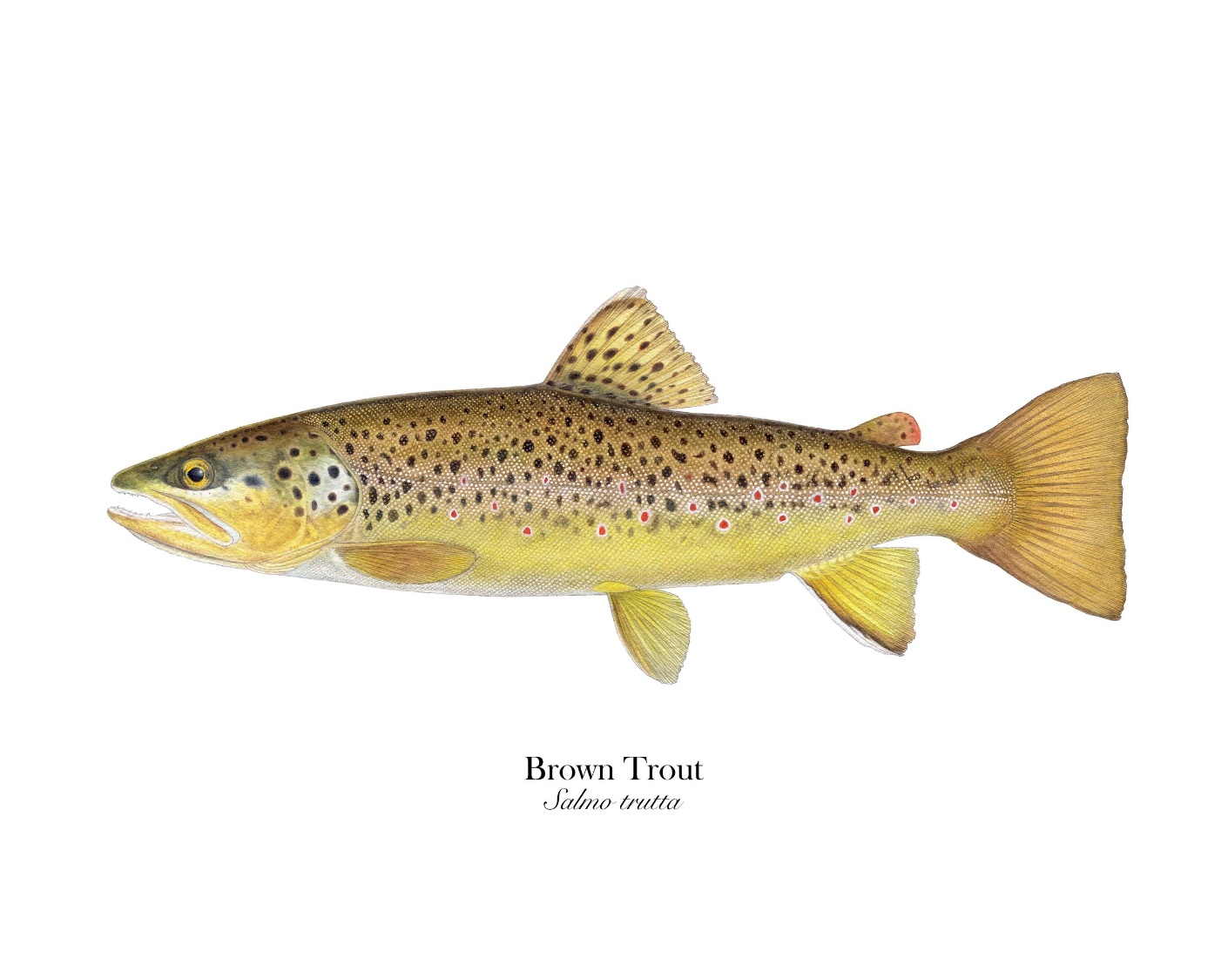
Brown Trout

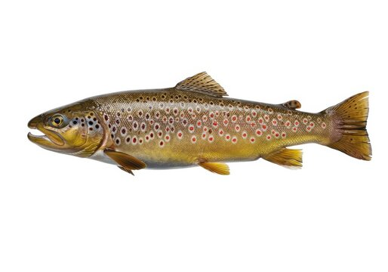

The wild brown trout is a medium to large freshwater predatory fish. Its diet consists of small insects’ larvae, small fish and flying insects. Often found in shallow water throughout the warmer months and especially when young.

Some defining features include:
- Golden brown appearance.
- Small black and or red spots with pale edges.
- A hook jaw (kype) for males that appears once spawning age is reached.

An interesting fact of brown trout is that some may return to the sea from rivers before coming back to spawn. These are then called sea trout!

Rainbow Trout
Now I have included some information about the fish that are farmed here on site at the Llyn Brenig Fish Farm.
The Brenig Fish farm been an active farm for over 30 years now with numerous different species of trout being grown on in the cages during that time.
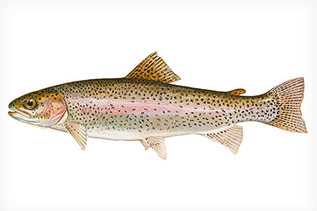
The main species throughout this time has been the Rainbow Trout. Like the brown trout the rainbow is a medium to large freshwater predatory fish that has a diet of small insect larvae, small fish and other flying insects. The farmed fish we produce here at Brenig are “triploids” which means they are neither male nor female. This is because they are a nonnative species to the country, and we do not want them to naturally reproduce as they would certainly threaten our wild fish populations here in Wales.

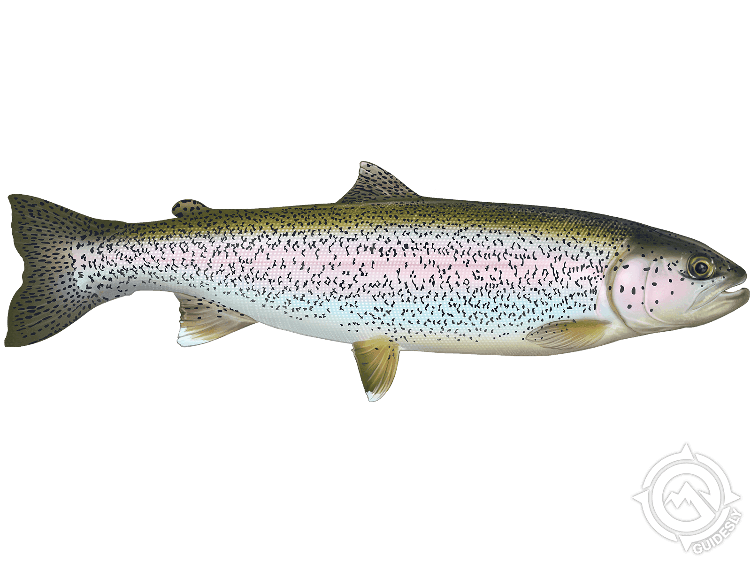

Some defining features include:
- Slivery body with black spots

- Distinct red/pink stripe along flank
Depth/Diet and Water Quality

Although this gives a general overview of the fish species here at Llyn Brenig there are a few things to take into consideration. Ultimately not all fish will look the same and there are several factors that may influence how and why a fish may have different colourations and dimensions.
First, we can look at the diet of the fish. Some rainbow trout may eat more fly life than others and some may eat more fish than others. This will leave the same fish looking slightly different however it is still the same species.
A rainbow trout that eats more fish proteins will ultimately be a larger fish than the rainbow trout just eating fly life. Also, where this food source is found can influence the fish. A rainbow trout that eats mainly fish will live slightly deeper in the water column that the one eating mainly fly life. This will influence the colour of the fish as the light does not penetrate the deeper water the fish that feed deeper tend to be darker in colour than the fish that feed high in the water.
This needs to be considered when identifying which species of fish we are looking at.
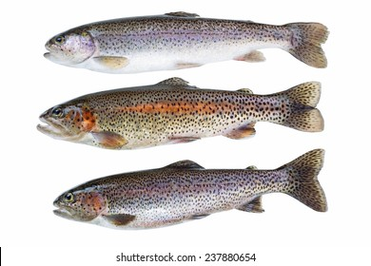
Here is an example of this below. These are all rainbow trout, but all have different characteristics due to environmental conditions and diet.

The Ospreys diet

Here at Llyn Brenig we also have a pair of Ospreys that come for a stay with us! They are fish eating birds that not only eat fish from Llyn Brenig but has been seen to bring fish from the sea back to the nest here at Brenig!
Below I have included some of the fish species that the osprey has brought back to the nest over the years!

Flounder
The flounder is a flat fish species with an oval body shape. They can grow up to around 50cm and live close if not on the bottom of seabed. They eat small crustaceans and other small fish species. An interesting fact is that these fish start life like a normal upright fish and as they get older one eye migrates over to the same side as the other eye and they become flat ambush predators.
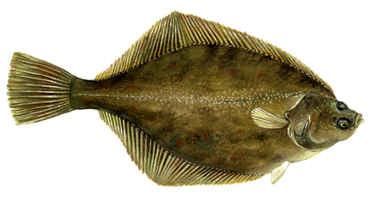
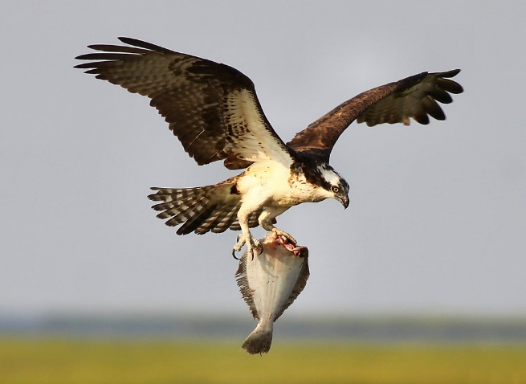

Some defining features include:
- Flat, oval body shape
- Pointed snout
- Squared cut tail
- White underside
Bass

The bass is another predatory sea fish species that is found around the coastline of Wales. When smaller usually found in shoals and found in shallow water such as estuaries. They can grow to considerable size with a large specimen being around 10lbs.
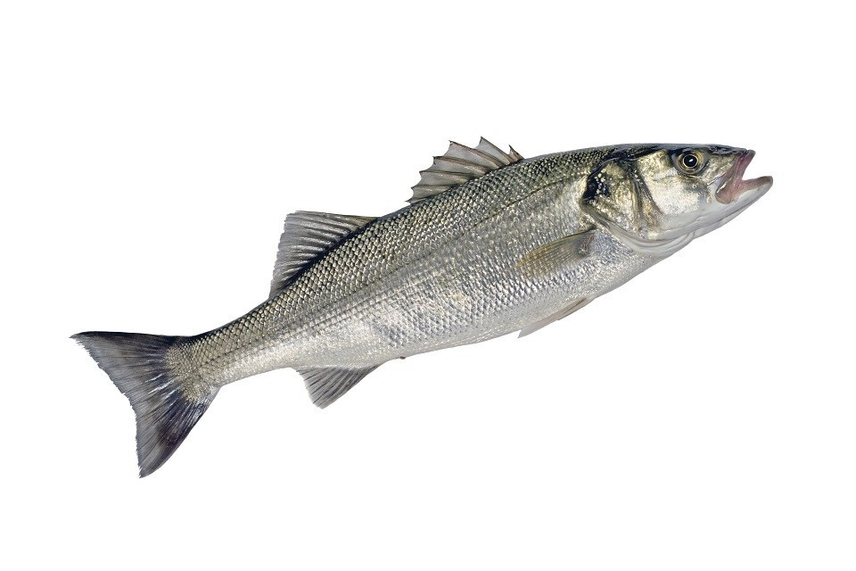
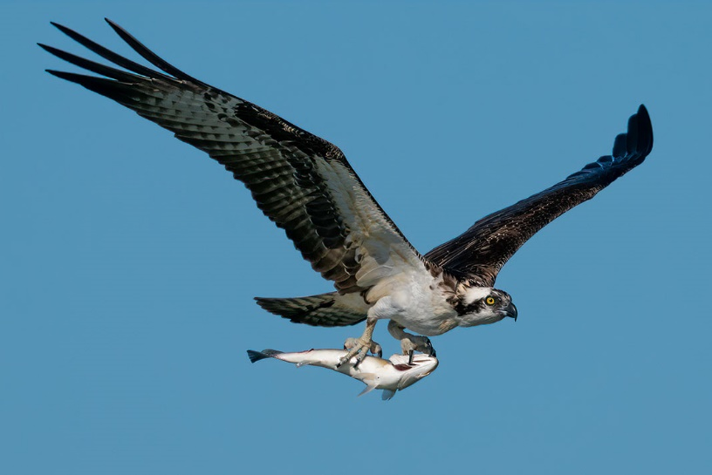

Adults spend winters offshore and move inshore during summer months. They shoal in early summer to spawn and juveniles stay in shallow waters for at least a year.

Some defining features include:
- Silver colouration
- Two dorsal fins
- Black edge to gill cover
- White underside

Mullet

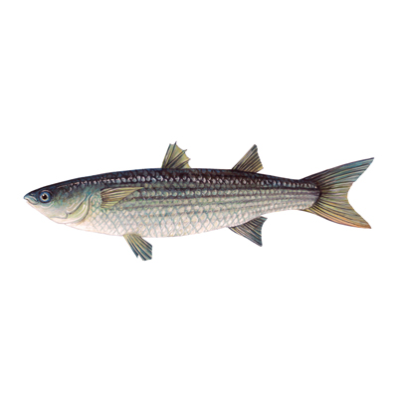
The mullet is another sea fish species that is often found around estuaries and harbours. They are highly adaptable and can often be found in both brackish and freshwater systems. The most common species are the thick-lipped, thin-lipped, and golden grey mullet. They are renowned for being hard to catch as they eat tiny organisms and algae making angling for them very tricky. As a result of where they find their food in the shallows, they are also easily caught by the ospreys!
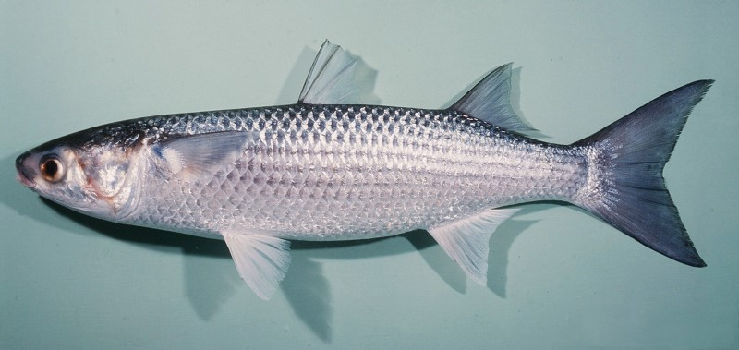

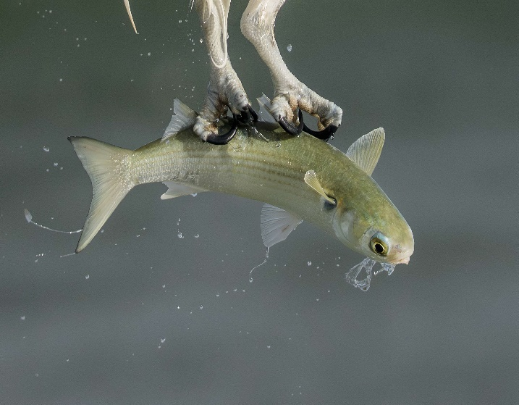

some defining features:
- Large blue, grey body
- 2 dorsal fins
- Small smooth lipped mouth

Grayling

The Grayling is known as the “lady of the stream” for its graceful appearance! It lives well oxygenated rivers and streams throughout the country. It is said that only rivers and streams with exceptional water quality can host the grayling. The closest known grayling is found close to Llyn Brenig in the local River Alwen and River Dee. Their diet consists of small invertebrates, insect larvae, shrimp, and sometimes salmon and trout eggs.

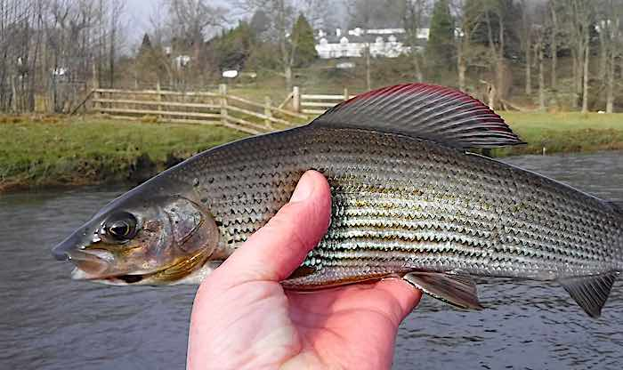
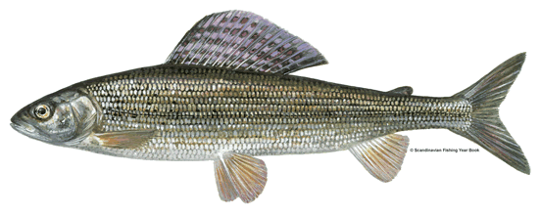

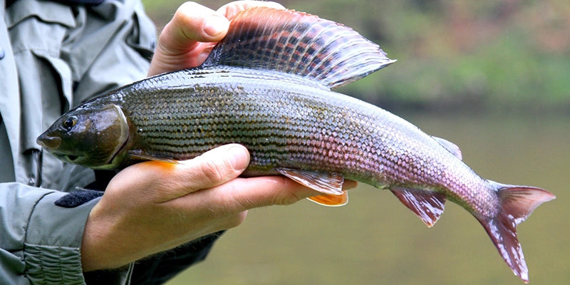

some defining features include:
- Silvery appearance.
- Often purple and red tip fins
- Large sail like dorsal fin.
- Small mouth

