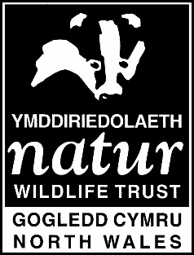
Repair Porth y Corwgl with Living Seas
Porth y Corwgl is renowned for gathering microplastics, and over the years, this has built up in layers in the sand. The aim is to remove as much of the microplastic pollution as possible. We will survey the beach in order to track the clean-up operation and to hopefully (over time) make a visible difference to plastic pollution at this beautiful beach. Every session, we will meet at Rhoscolyn beach car park and walk over from there. Bring a flask for a panad break! Covid-regulations apply for all of these events. Please get in touch with Eve if you want to know more info: eve.grayson@northwaleswildlifetrust.org.uk or 07772878999. For now, to get an idea of numbers, if you can let me know if you’re thinking of coming that would be great.
Gobeithio eich gweld chi ar y traeth! Hope to see you on the beach!
Diolch yn fawr!
Date | Time | Any other information
Thurs 22nd April 2021 | 10am-12:30pm | Celebrating Earth Day. This event is closed to the general public.
Mon 3rd May 2021 | 10am-12:30pm | Bank Holiday Monday
Mon 14th June 2021 | 5pm-7:30pm | Part of Keep Wales Tidy’s Spring Clean Cymru.
Wed 14th July 2021 | 10am-12:30pm
Friday 13th August 2021 | 10am- 12:30pm | School Holidays – potentially open to the public.

