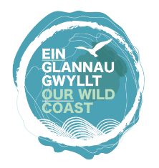
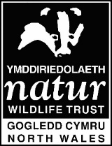
Youth Forums
Online Code of Conduct
With this Forum, we hope to create a safe space online where you feel happy to join in our sessions and talk to us if you need to.
What you can expect from us:
- Interesting activities
- An opportunity to express your creativity/thoughts/opinions about wildlife and wild spaces
- People to talk to

What we expect - for you to turn up to sessions as you would if we were meeting face to face i.e.
- on time
- fully dressed (not in PJs)
- being mindful of your language
- being respectful to the other people in the session
- ideally in a quietish space if you can find one
- mute your microphone when not speaking so that the sound quality is better for everyone

A few things to know - your safety:
- There will usually be another member of staff in the sessions with us to help things run smoothly
- Please remember that you are online. Don’t post anything that you might want to take back later.
- Please do not record video or take screenshots without prior consent and permission.
- We can’t promise to keep anything confidential. If we think you or someone else is at risk of significant harm we may need to talk to someone else about it.
I have read and understood this code of conduct and agree to follow it.
NAME:
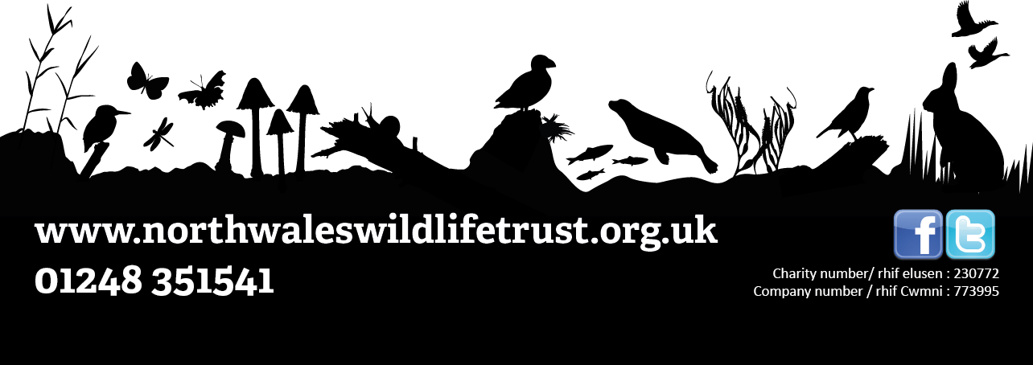
SIGNED:
DATE:

