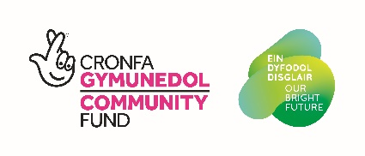
Cais Warden Cadwraeth/Conservation Ranger Application

Enw/Name

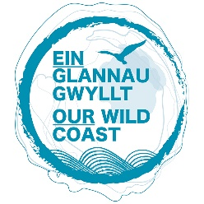
Oed/Age

Dyddiad Geni/D.O.B.
Cyfeiriad/Address

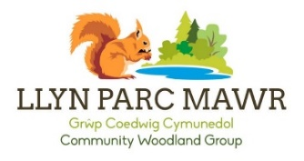
Gwybodaeth cysylltu/ Contact information

Atebwch y cwestiynau canlynol (dim mwy na 150 o eiriau ym mhob adran), os gwelwch yn dda.
Please answer the following questions with no more than 150 words per section. Continue on a separate sheet if needed.
Dywedwch wrthym am brofiad yr ydych wedi’i gael ym myd natur a oedd yn gofiadwy
Tell us about an experience you have had in nature that was memorable

Lle ydach chi’n gweld eich hun mewn deg mlynedd?
Where do you see yourself in 10 years’ time?

Mewn 5 gair, sut fyddech chi’n disgrifio eich hun?
In 5 words, how would you describe yourself?

Mae gyrfa mewn Cadwraeth ar gael i nifer eang o bobl, ac rydym yn edrych am grwpiau o bobl o bob cefndir i gymryd rhan. Dywedwch wrthym am eich sgiliau a’ch diddordebau.
Conservation careers are open to a wide range of people, and we are trying to find a diverse group of people to take part. Tell us a little bit about your skills and interests.

Fasech chi ar gael i fynychu cyfarfod cyn yr hyfforddeiaeth ar ddydd Mercher, 1af mis Mehefin, 5:30yh - 8:30yh?
Would you be available to attend a meeting before the traineeship on Wednesday, 1st July, 5:30pm – 8:30pm?
BASWN/YES

NA FASWN/NO

ANSICR/UNSURE

E -bostiwch ceisiadau wedi i’w cwblhau at Andy.Ocallaghan@northwaleswildlifetrust.org.uk os gwelwch yn dda, neu anfonwch nhw yn y post at:
Ymddiriedolaeth Natur Gogledd Cymru
Llys Garth,
Ffordd Garth
Bangor,
LL57 2RT

Please email completed applications to Andy.OCallaghan@northwaleswildlifetrust.org.uk or alternatively send them to:
North Wales Wildlife Trust,
Llys Garth,
Garth Road,
Bangor,
LL57 2RT

Diolch yn fawr, a phob lwc!
Thank you, and good luck!

