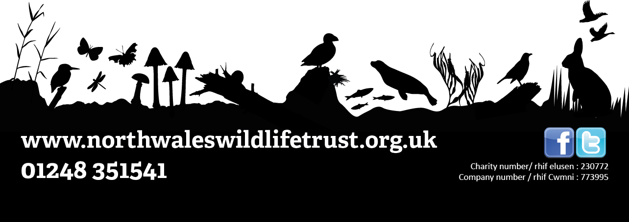

**JOB DESCRIPTION:** Conservation Trainee

**Length of post:** Two week placement, Monday to Friday starting on the 20th July

**Number of posts available:** 15 conservation trainees will be chosen

**Location:** Llyn Parc Mawr, Newborough ***(Transport from Bangor will be provided)***

**Responsible to:** Andy Charles-O’Callaghan (NWWT)

***Do you have an interest in wildlife or nature? Are you keen on learning more about practical conservation and how it works on the ground?***

North Wales Wildlife Trust and Llyn Parc Mawr Community Woodland Group are joining forces this summer to offer a unique training opportunity to young people aged 16 to 24 and living in North West Wales. This has been set up to give young people an opportunity to gain practical experience in conservation, learn more about the natural environment and gain a range of accreditations to help towards a future career in conservation.

The role will include the following:

1. Practical conservation training using a range of hand tools
2. REC first aid one day course
3. Managing a nature reserve
4. Species ID
5. Marine and land conservation – what’s the difference?
6. Coordinating people
7. Involving the local community – how and why?
8. Running citizen science.

You do not need to have any specific qualifications to take part. All we ask for is that you are free to attend each day, are able to follow health and safety instructions, and that you have an interest in learning about nature and conservation.

**What next?**

To download the application form, please visit the ‘Volunteering Opportunities’ page of the North Wales Wildlife Trust website.

**Important application information**

We want to know all about what interests you about conservation and what motivates you to want to take part, so make sure you tell us all about your own passions and interests when writing your application! **Please also include an email address and your name so we can contact you (parent/guardian email if you are under 18).**

**Please email completed applications to Andy.OCallaghan@northwaleswildlifetrust.org.uk by Friday, 5th June 2020 and good luck!**