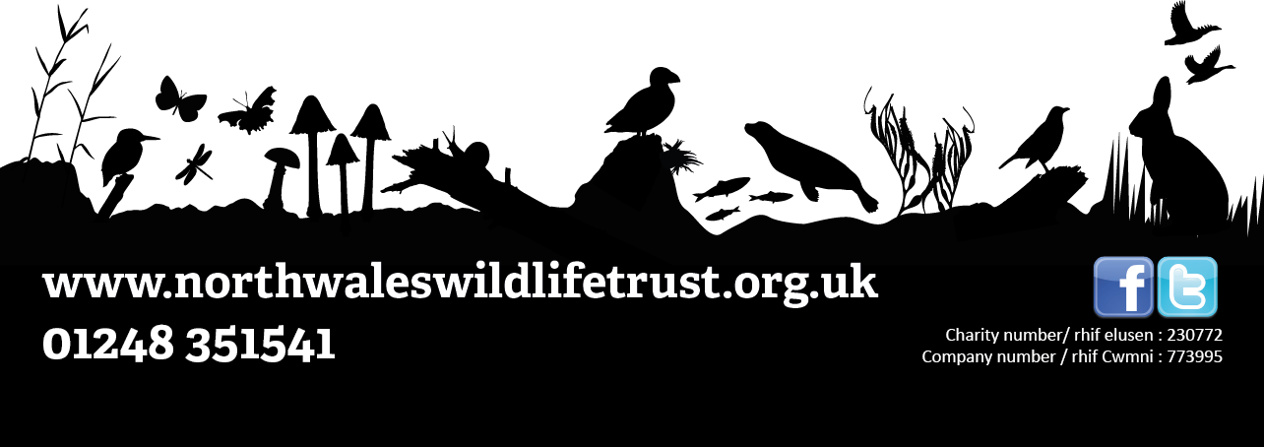

**JOB DESCRIPTION:** Conservation Ranger

**Length of post:** Two week placement, Monday to Friday beginning the 22nd July

**Number of posts available:** 10 conservation rangers will be chosen

**Location:** Llyn Parc Mawr, Newborough ***(Transport will be provided)***

**Responsible to:** Andy Charles-O’Callaghan (NWWT),

***Do you have an interest in wildlife or nature? Are you keen on learning more about practical conservation and how it works on the ground?***

North Wales Wildlife Trust and Llyn Parc Mawr Community Woodland Group are joining forces this summer to offer a unique role to young people aged 16 to 24, and living on Anglesey or Arfon in Gwynedd. This has been set up to give young people an opportunity to gain practical experience in conservation, learn more about the natural environment, and leave after the two week placement with a range of AQA qualifications and a portfolio to put towards a future career.

The role will include the following:

1. Practical conservation training using a range of hand tools
2. REC first aid one day course
3. Managing a nature reserve
4. Species ID
5. Marine and land conservation – what’s the difference?
6. Coordinating people
7. Involving the local community – how and why?
8. Running citizen science.

You do not need to have any specific qualifications to take part. All we ask for is that you are free to attend each day, are able to follow health and safety instructions, and that you have an interest in learning about nature and conservation.

**What next?**

To download the application form, please visit the North Wales Wildlife Trust website and go to the Jobs section.

**Important application information**

We want to know all about what interests you about conservation and what motivates you to want to take part, so make sure to talk about your own passions and interests when writing your application! **Please also include an email address and your name so we can contact you (parent/guardian email if you are under 18).**

**IMPORTANT - If you are travelling from Gwynedd, please contact Andy before applying.**

**Please email completed applications to Andy.OCallaghan@northwaleswildlifetrust.org.uk by Friday, 7th June 2019 and good luck!**