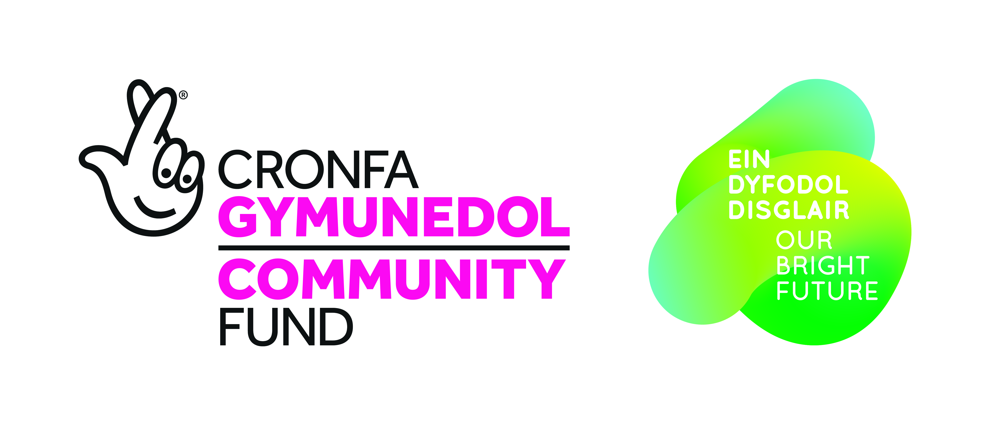
Conservation Ranger Application/Cais Warden Cadwraeth

Name/Enw

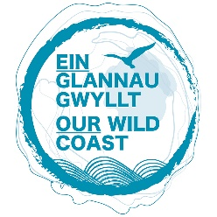
Age/Oed

D.O.B./Dyddiad Geni
Address/Cyfeiriad

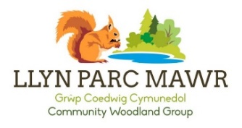
Contact information/Gwybodaeth cysylltu

Please answer the following questions with no more than 150 words per section. Continue on a separate sheet if needed.
Atebwch y cwestiynau canlynol (dim mwy na 150 o eiriau ym mhob adran), os gwelwch yn dda.
I would like to be a conservation ranger because …
Hoffwn fod yn warden cadwraethol oherwydd ...

Conservation careers are open to a wide range of people, and we are trying to find a diverse group of people to take part. Tell us a little bit about your skills and interests.
Mae gyrfa mewn Cadwraeth ar gael i nifer eang o bobl, ac rydym yn edrych am grwpiau o bobl o bob cefndir i gymryd rhan. Dywedwch wrthym am eich sgiliau a’ch diddordebau.

Please email completed applications to Andy.OCallaghan@northwaleswildlifetrust.org.uk or alternatively send them to:
North Wales Wildlife Trust,
Llys Garth,
Garth Road,
Bangor,
LL57 2RT

E -bostiwch ceisiadau wedi i’w cwblhau at Andy.Ocallaghan@northwaleswildlifetrust.org.uk os gwelwch yn dda, neu anfonwch nhw yn y post at:
Ymddiriedolaeth Natur Gogledd Cymru
Llys Garth,
Ffordd Garth
Bangor,
LL57 2RT
Diolch yn fawr, a phob lwc!

